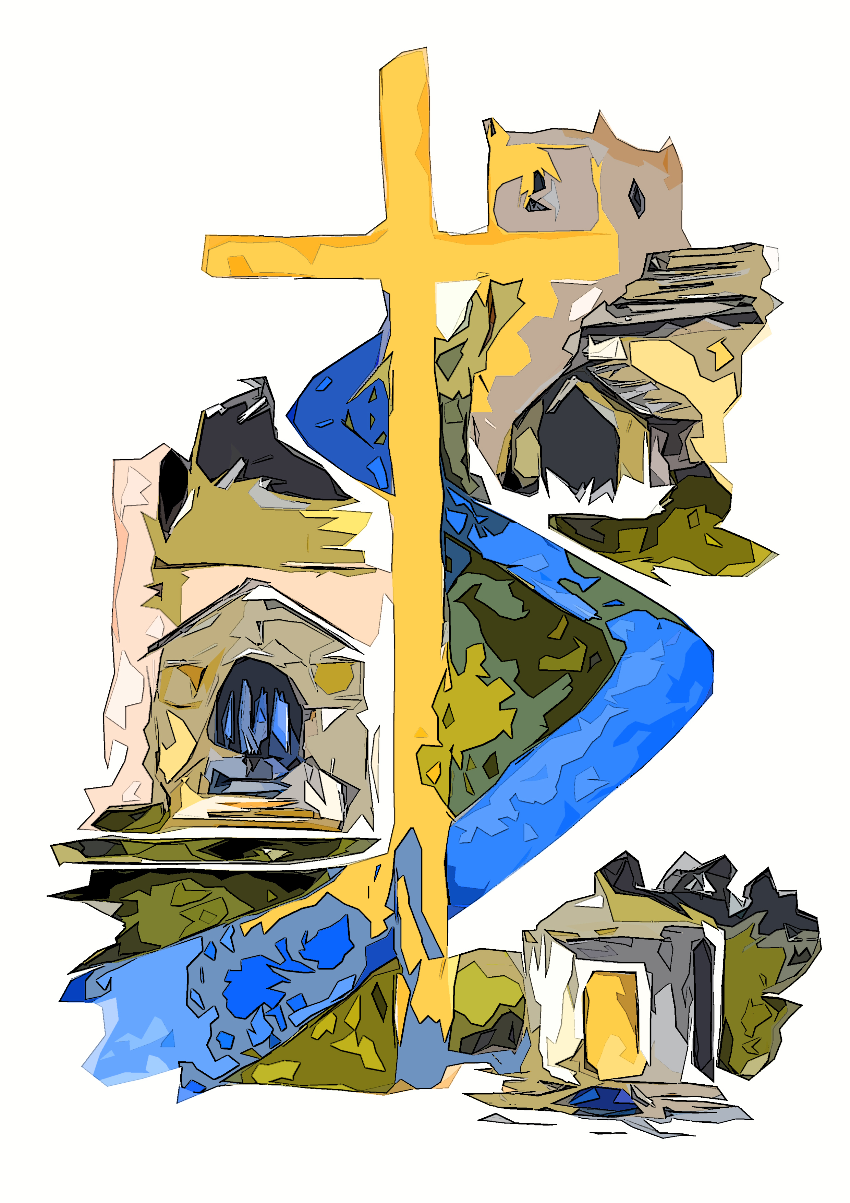
WEDDING ENQUIRY FORM
Parish of Broughton, Martin, and Thornton
Diocese of Leeds

Dear Wedding Couple,

We share in your joy at deciding to commit yourselves to one another through marriage and we are pleased that you are considering being married in one of our churches. You can be assured of our prayers as you prepare for your wedding day.

As with all things recognised in law there are a number of administrative hurdles to be overcome and this form is part of that process. In law all people, baptised or otherwise, are entitled to be married in the Church of England parish where they reside. So if either you or your partner live in the parish of Broughton, Marton and Thornton, the process is very simple. But there are other factors that may entitle you to be married in one of our churches and they are detailed below. If no existing connection exists with our parish you can create one by attending our Sunday service for 6 months before your wedding day.

Marriage is understood by the Church of England to be a solemn declaration made by a man and a woman, before God and witnesses. It is understood as a permanent union, blessed by God, for the right ordering of society. The Church also understands that for reasons beyond our control marriages also break apart. If either, or both, partners have been previously married then, at the discretion of the priest, you may still be able to be married in one of our churches. You are encouraged to come and talk to us about your own circumstances and be aware that no further
marriage can take place without a document of legal annulment or a decree absolute in place.

The attached form should be completed to the best of your knowledge and brought, with the relevant documentation and evidence, to our arranged meeting in order to complete your wedding booking and set a date. We have a busy Parish diary and it may not be possible for you to have your chosen day - although we try very hard to accommodate your wishes.

There is an information sheet detailing acceptable forms of evidence for establishing a qualifying connection alongside this form and your asked to consult it so that all the documentation is in place when you come to for your meeting. You will need to bring with you:

- Both partners passports, or other identity documents as listed on page 7.
- Proof of address AND evidence establishing a qualifying connection to the parish.
- Any legal annulment or decree absolute as might apply.
- A £60 deposit to secure the date of your wedding.

The Church of England charges a standard fee for weddings which changes from year to year and these can be given to you at the time of booking your wedding so you’ll know what the cost is. The full cost of the wedding (less the deposit) will be payable either in cash or bank transfer at your rehearsal, which is usually one week before the wedding or if you intend to pay by cheque these are paid one month before the wedding day.
 | Groom’s Details | Bride’s Details
Full Name
Current Address

Address since
Phone No.
Email
Date of Birth
Age at proposed date of Wedding
Occupation/Profession

Have they been married before? | Yes/No | Yes/No
Is the previous partner still living? | Yes/No | Yes/No
Have they ever been in a civil partnership? | Yes/No | Yes/No
Are they a foreign national? | Yes/No | Yes/No
Which is your Parish Church (for Banns)
Are they related, or are they connected by marriage? If so how?

Keeping in touch: if address is due to change, note new address here.

Which Church do you wish to be married at?

On which date, and at what time?

 | Groom’s Father | Bride’s Father
Full name
Occupation / Profession
Deceased? | Yes/No | Yes/No
 | Groom’s Mother | Bride’s Mother
Full name
Occupation / Profession
Deceased? | Yes/No | Yes/No
 | Groom’s Parent  (if different to above) | Bride’s Parent  (if different to above)
Full name
Occupation / Profession
Deceased? | Yes/No | Yes/No
 | Groom’s Parent  (if different to above) | Bride’s Parent  (if different to above)
Full name
Occupation / Profession
Deceased? | Yes/No | Yes/No

ESTABLISHING A QUALIFYING CONNECTION

Everyone is entitled to be married in the Parish in which they are resident. In order to be married in a different parish you are required to establish a ‘Qualifying Connection’ in accordance with Church of England Marriage Measure 2008. Such a connection needs to be demonstrated with evidence and so you may be required to present documentation to establish this connection. You should bring such evidence with you when you come to book your wedding.

A person has a qualifying connection with a parish if…

(a) that person was baptised in that parish (unless the baptism took place in a combined rite which included baptism and confirmation) or is a person whose confirmation has been registered within the parish, or

(b) that person has at any time had his or her usual place of residence in that parish for a period of not less than six months;

(c) that person has at any time habitually attended public worship in that parish for a period of not less than six months;

(d) a parent of that person has during the lifetime of that person had his or her usual place of residence in that parish for a period of not less than six months or habitually attended public worship in that parish for that period; or

(e) a parent or grandparent of that person has been married in that parish. The parties should approach the minister of the parish in the first instance to establish that they have a qualifying
connection and its nature. Details of the qualifying connection should then be obtained from the couple.

Please complete the section on page 4 to establish which of these qualifying connections applies to you. If either of you are currently resident in the parish then simply tick the first box and bring proof of address.

By law the minister must be satisfied with the documents provided and that they show a relevant connection in order to proceed. Further documentation may be required and the minister reserves the right to consult and refer particular cases to the relevant authorities in the Church to decide.

IDENTITY DOCUMENTATION

By law we are required to see and retain copies of identity documents proving your nationality. If you have a UK/ EEA or Swiss passport this is relatively straight-forward. If you do not hold a passport but would be entitled to one then other documentation can be provided instead. For nationals of other countries there is an additional licence to be obtained before the marriage can take place and we can talk you through how this is done. Page 5 of this document will be completed by the Deacon/Priest at the time of booking but also details other proofs of ID that are
acceptable so you can have these ready at the time of booking.

EXTERNAL BANNS

If either/both of you live outside the parish it will be necessary to have your Banns read in the parish(es) in which you reside. We can help you find which is your home parish or alternatively visit http://www.achurchnearyou.com and use your postcode to locate your parish of residence. It is important to get this underway as soon as possible as without the relevant Notification of Banns Certificate from the other parish(es) we will not be able to conduct the service. Please ask us about this when you come to book your wedding.

WEDDING PREPARATION

All couples married in the Church undergo some form of preparation. This is discussion based and not any kind of assessment of your relationships. Many couples comment on this being one of the positive and distinctive aspects of being married in Church. This discussion will usually be arranged with the priest conducting your wedding.

Have either party been previously married? If yes, please state who. (If yes, a further discuss will need to take place with the Priest) | Yes / No
Please state which qualifying connection applies to you:
a) [baptism and/or confirmation in the Parish]
b) [lived in the Parish for at least 6 months]
c) [attended Church of England services for 6 months or more in the Parish]
d) [Parent lives/lived or worships/worshipped in the Parish]
e) [Parent/grandparent married in the Parish]
Please detail what evidence you have provided:
(evidence needs to be brought with you and should show dates covering a relevant 6 month period - please contact us if you require further information or unsure of what evidence might count. Further information can be found at https://churchsupporthub.org/marriage-measure/)

The person to whom the qualifying connection applies should sign the following declaration:
I________________________ ___, wish to be married to ______________________________

according to the rites of the Church of England in the Parish of Broughton, Marton and Thornton, Diocese of Leeds, by virtue of having a qualifying connection with the parish under the Church of England Marriage Measure 2008.

I confirm that the information and answers given in and supplied with this form are correct to the best of my knowledge and belief.

Signed ____________________________________________

Date ____________________________________________

If any of your identity documents, or evidence presented alongside this form, are in a name other than the one you use, you are required to provide legal proof of a name change. In the case of evidence presented for a qualifying connection, you should be able to explain how the difference has arisen.

Do either/both parties have a different name than that shown in the documents provided? | Yes/No
Please give details:

For the purposes of data protection law, the data controller is the Minister of the parish, Reverend Robert Findlow and the PCC of the Parish of Broughton, Marton, and Thornton, who will use the information on this form to ensure that the legal requirements relating to the marriage are compiled with and to make arrangements for the wedding ceremony. The Minister and PCC will only share
the information with those who need to see it for those purposes. Your data may be stored on behalf of the Minister, or the PCC either on systems owned by the Archbishops’ Council of the Church of England or other software. After your wedding, your church would love to keep in touch with you on anniversaries and to let you know about services and events that may interest you. If you are happy for the church to keep in touch with you in this way, please confirm Yes/No (strike out what is not applicable)

For office use only:
First meeting |  | Banns
Prep event(s)
Wedding Choices
Officiant |  | Hymns
Entrance |  | Recessional
Reading(s) |  | Other
Useful contacts for this couple:
Photographer |  | Bells
Videographer
Flowers

